Shobrooke Parish Council
Notice of Meeting of Parish Council
Dear Councillors
I hereby give notice that the meeting of the above-named Parish Council will be held on Wednesday 16 November 2022 at 7.30pm
All members of the Council are hereby summoned to attend for the purpose of considering and resolving upon the Business to be transacted at the meeting set out hereunder.
Dated this 10 October 2022

Signed
Clerk to the Parish Council shobrookepc@outlook.com

Public Participation
Members of the public are invited to give their views and ask questions on issues on this agenda or to raise issues for future consideration by the Parish Council. Limited to 15 minutes.

Formal Business
(Members of the public may not take part in the formal business of the Parish Council except under special circumstances)

01/11/22 Apologies
To receive apologies

02/11/22 Declaration of Interest
2.1 Register of Interests (ROI). Councillors to update as required
2.2 Personal Interests (PI). Councillors must declare any personal interest in items on the agenda and their nature.
2.3 Disclosable Pecuniary interest (DPI). Councillors must declare any pecuniary interest in items on the agenda and their nature and they must leave the meeting for that agenda item.

03/11/22 Minutes of the last meeting held on Wednesday 19 October 2022 (previously circulated)
To be agreed and signed as a true record

04/11/22 To consider any applicants for co-option
Standing orders to be suspended to allow discussion with candidates.

05/11/22 Mid Devon District Council
5.1 Planning Applications:
None
5.2 Planning Decisions:
None
5.3 Public consultation on an Air Quality Supplementary Planning Document and Non Statutory Interim Planning Policy Statement: Climate Emergency – email circulated
5.3 Report from MDDC Councillor, Cllr Graeme Barnell on MDDC business relevant to the parish including update on affordable housing

06/11/22 Finance
6.1 Parish Council receipts Current Account: None
6.2 Parish Council payments Current Account:
 | Payee | Purpose | Amount £
6.2.1

6.3 To approve authorisers/signatories for this month’s payments
6.4 Balances:
6.4.1 Parish Council Current Account balance: £4,498.18
6.4.2 Parish Council Footpath balance (in above current account figure): £311.74
6.4.3 Parish Council Reserve Account balance: £7,799.96(£4,000.00 ringfenced for play equipment)
6.5 Financial Statement and Budget Monitor – attached.

07/11/22 Road and Footpaths
7.1 Outstanding Road and Footpath issues
7.2 New issues identified

08/11/22 Parish Council
8.1 To consider Mid Devon Wildlife Scheme – email circulated

09/11/22 Councillor’s Reports
9.1 To consider any Councillor reports for areas of responsibility
9.2 Playing Fields
9.2.1 To note weekly inspections reports and update on maintenance
9.2.2 Update on new play equipment

10/11/22 Clerk’s Report
10.1 Update on recruitment of new clerk

11/11/22 Devon County Council
11.1 Report from DCC Councillor, Cllr M Squires on DCC business relevant to the parish

12/11/22 Miscellaneous Correspondence
Various newsletters circulated.
A list of any other correspondence will be available at the meeting

13/11/22 Minor Matters and Items for Future Agenda
Each Councillor is requested to use this opportunity to report minor matters of information not included elsewhere on the agenda and to raise items for future agendas. Councillors are respectfully reminded that this is not an opportunity for debate or decision making.

14/11/22 Date of next meeting: Wednesday 21 December 2022, at 7.30 pm, at the Village Hall

End of formal business

Agenda Item 6.5

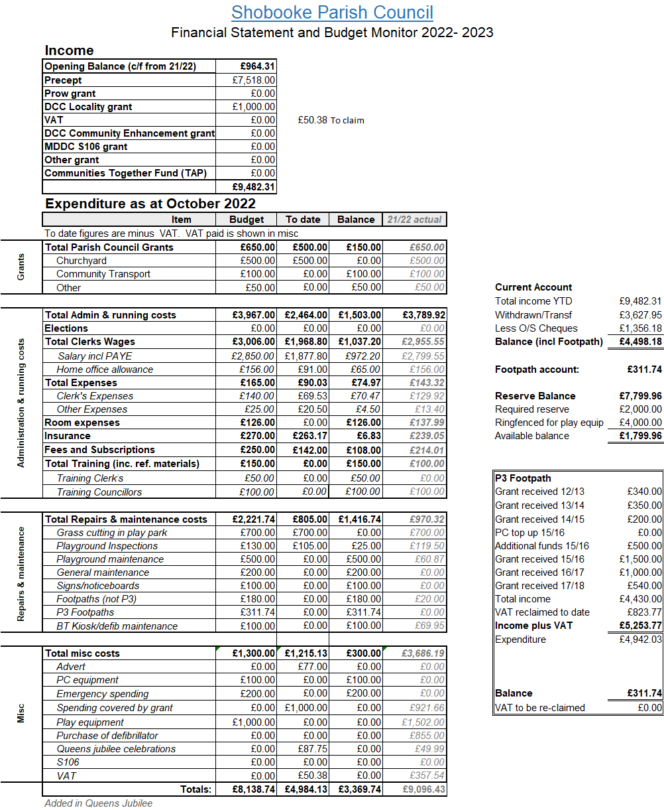

Shobrooke Parish Council
Clerks salary and expenses breakdown
October 2022
Salary for Sep  Salary for Oct | 20 hours’ x £11.50  20 hours’ x £11.50  PAYE |  | £230.00  £230.00  £66.20
£431.60
Expenses
 |  | Item | Quantity |  | Charge
 |  | Home office allowance* | 2 |  | £26.00
 |  | Envelopes 4p each  Large envelope  2nd class stamp (68p) | 2  0  3 |  | £0.08  £0.00  £2.04
 |  | 1st class stamp (95p)
 |  | Printing 8p per sheet  Mileage x 3 visits | 17 sheets  18 miles |  | £1.36  £8.10
 | * Shobrooke portion of 50/50 split with NSC
Expenses subtotal £37.58

Total £431.38

Clerk was paid one month in arrears
Started September 2014 but first pay was October 2014

