Shobrooke Parish Council
Notice of Meeting of Parish Council
Dear Councillors
I hereby give notice that the meeting of the above-named Parish Council will be held on Wednesday 20 April 2022 at 7.30pm
All members of the Council are hereby summoned to attend for the purpose of considering and resolving upon the Business to be transacted at the meeting set out hereunder.
Dated this 13 April 2022
Signed 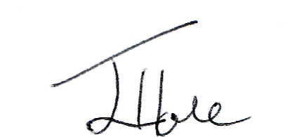 Jane Hole
Clerk to the Parish Council shobrookepc@outlook.com 01392 851148

Public Participation
Members of the public are invited to give their views and ask questions on issues on this agenda or to raise issues for future consideration by the Parish Council. Limited to 15 minutes.

Formal Business
(Members of the public may not take part in the formal business of the Parish Council except under special circumstances)

01/04/22 Apologies
To receive apologies

02/04/22 Declaration of Interest
2.1 Register of Interests (ROI). Councillors to update as required
2.2 Personal Interests (PI). Councillors must declare any personal interest in items on the agenda and their nature.
2.3 Disclosable Pecuniary interest (DPI). Councillors must declare any pecuniary interest in items on the agenda and their nature and they must leave the meeting for that agenda item.

03/04/22 Minutes of the last meeting held on Wednesday 16 March 2022 (previously circulated)
To be agreed and signed as a true record

04/04/22 To consider any applicants for co-option
Standing orders to be suspended to allow discussion with candidates.

05/04/22 Mid Devon District Council
5.1 Planning Applications:
22/00371/FULL- Erection of dwelling following demolition of Dutch barn and stable and formation of vehicular access at West Efford Farm, Efford, Shobrooke – to note committee date 20 April 2022
5.2 Planning Decisions: None
5.3 Report from MDDC Councillor, Cllr Graeme Barnell on MDDC business relevant to the parish

06/04/22 Finance
6.1 Parish Council receipts Current Account: HMRC VAT refund £364.74; MDDC - Precept £7,518.00
6.2 Parish Council payments current account:

Item | Payee | Purpose | Amount £
6.2.1 | DALC | Affiliation fees | 120.98
6.2.2 | J Hole | Salary and expenses | 242.58
6.3.3 | HMRC | PAYE | 14.00

6.3 To approve authorisers/signatories for this month’s online payments
6.4 Balances:
6.4.1 Parish Council Current Account balance: £7,978.75
6.4.2 Parish Council Footpath balance (in above current account figure): £311.74
6.4.3 Parish Council Reserve Account balance: £7,799.10 (£4,000.00 ringfenced for play equipment)
6.5 Financial Statement and Budget Monitor – attached.

07/04/22 Road and Footpaths
7.1 Outstanding Road and Footpath issues
7.2 New issues identified
Email re pot holes on road from A3072 to Exeter Cross

08/04/22 Parish Council
8.1 Update on number of seed packets required for under 16’s to celebrate the Queens Platinum Jubilee
8.2 Annual Parish Meeting (7pm on 18 May). MDDC Principal Housing Enabling and Forward Planning Officer will attend. To agree questions and support required.
8.3 Permissive path through allotments – to consider email received concerning broken signage, rotten and insecure fence posts, overhanging blackthorn shrub to the field entrance gate, and untrimmed holly hedge in the field gate entrance. (photos circulated separately)
8.4 Community Resilience Plan – to consider if we wish to apply for a grant for resilience equipment such as torches, first aid kits.

09/04/22 Councillor’s Reports
9.1 To consider any Councillor reports for areas of responsibility
9.2 Playing Fields
9.2.1 To note weekly inspections reports
9.2.1 Update on grant application to Viridor

10/04/22 Clerk’s Report - None

11/04/22 Devon County Council
11.1 Report from DCC Councillor, Cllr M Squires on DCC business relevant to the parish

12/04/22 Miscellaneous Correspondence
Various newsletters circulated.
Temporary traffic notice 28 to 29 May – Enchanted Garden Ball at Shobrooke Park
A list of any other correspondence will be available at the meeting

13/04/22 Minor Matters and Items for Future Agenda
Each Councillor is requested to use this opportunity to report minor matters of information not included elsewhere on the agenda and to raise items for future agendas. Councillors are respectfully reminded that this is not an opportunity for debate or decision making.

14/04/22 Date of next meeting: Wednesday 18 May 2022, at 7.30 pm, at the Village Hall, proceeded by the Annual Parish Meeting at 7.00pm
End of formal business

Agenda Item 6.5

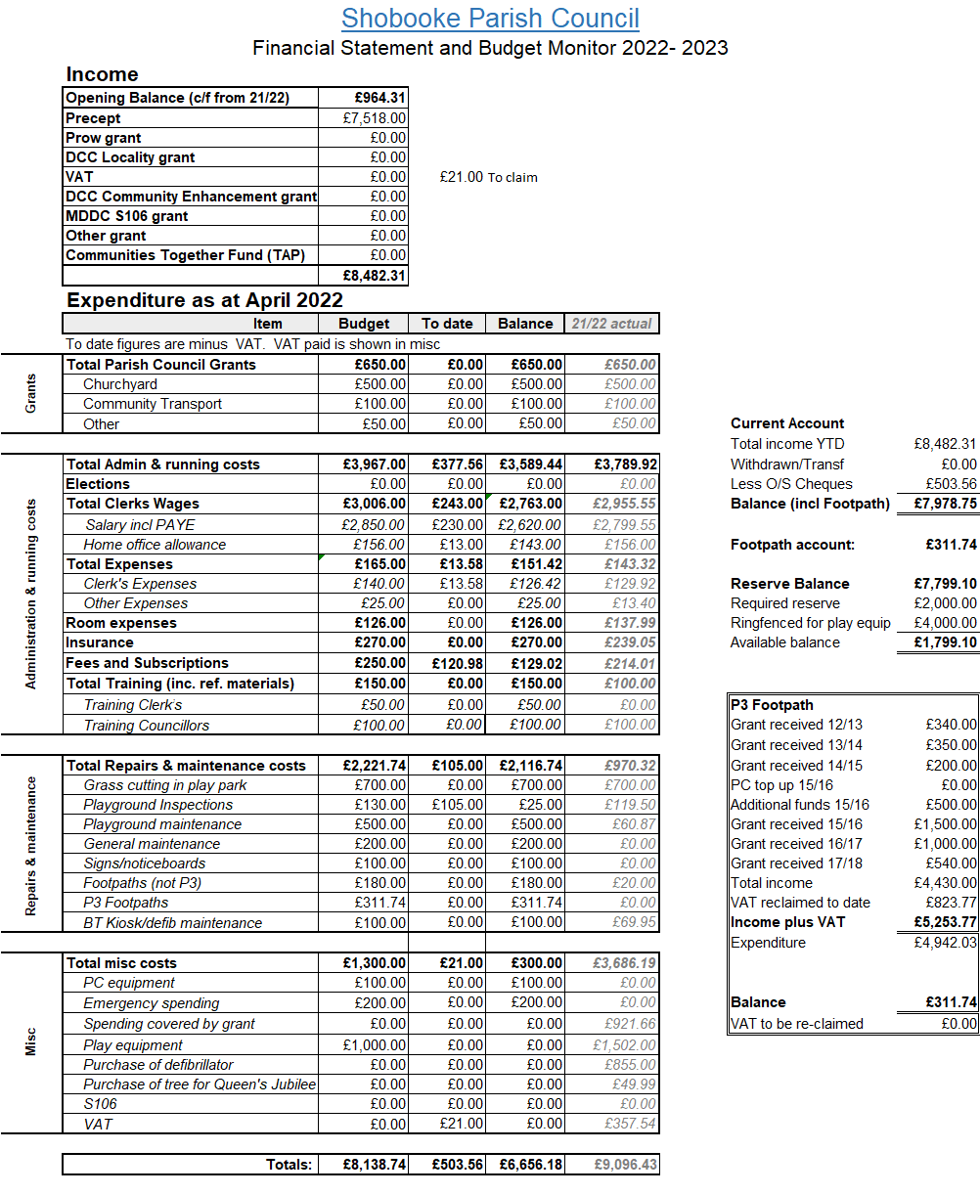

Shobrooke Parish Council
Clerks salary and expenses breakdown
April 2022
Salary for March | 20 hours’ x £11.50  PAYE |  | £230.00  £14.00
£216.00
Expenses
 |  | Item | Quantity |  | Charge
 |  | Home office allowance* | 1 |  | £13.00
 |  | Envelopes 4p each  Large envelope  2nd class stamp (66p) | 0  0  1 |  | £0.00  £0.00  £0.66
 |  | 2nd class stamp large | 0 |  | £0.00
 |  | Printing 8p per sheet  Mileage x 2 visits | 94 sheets  12 miles |  | £7.52  £5.40
 | * Shobrooke portion of 50/50 split with NSC
Expenses subtotal £26.58

Total £242.58

